ARCHITECTURE
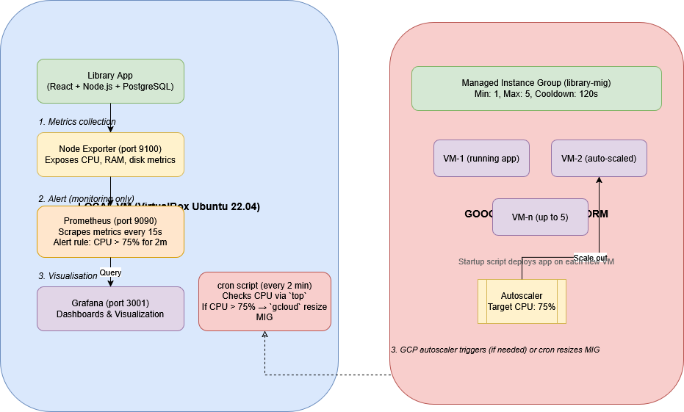

Link: https://drive.google.com/drive/folders/1wWWU8JEFy0F2L1vOfsASV8dLVvhcKSn3?usp=drive_link

GITHUB: https://github.com/aarondavidfernandes/library-system

I set out to build a system where a local virtual machine could monitor its own resources and, if things got too busy, automatically spin up a new instance on Google Cloud. The idea was simple: when CPU usage crosses 75%, the cloud takes over some of the load. For the sample application, I built a full‑stack Library Management System with React, Node.js, and PostgreSQL – something that feels real and has enough moving parts to make the demo meaningful.
I started by creating an Ubuntu VM inside VirtualBox on my Windows machine, giving it 4GB RAM and a bridged network so it could talk to the outside world. Inside that VM, I deployed the library app and then set up Prometheus, Node Exporter, and Grafana. Node Exporter exposes hardware metrics, Prometheus scrapes them every 15 seconds and fires an alert when CPU stays above 75% for two minutes, and Grafana gives me a live dashboard to watch the spikes. That monitoring stack was surprisingly easy to configure and immediately gave me confidence that I’d know exactly when the VM was struggling.
On the cloud side, I created a GCP project, enabled the Compute Engine API, and built a Managed Instance Group with an autoscaler set to a target CPU of 75%. The autoscaler can grow the group from one VM up to five, with a two‑minute cooldown. I also wrote a startup script that installs Node, PostgreSQL, and the library app on every new VM, so scaling out is completely hands‑off. To bridge the local VM to GCP, I added a simple cron script on the local machine that checks CPU every two minutes using the `top` command. When it sees usage above 75%, it calls `gcloud` to increase the instance group size by one. That way, the local VM triggers the scale‑out, and GCP’s own autoscaler can later scale back down when load drops.
To test everything, I ran the `stress` tool inside the local VM to hammer the CPU. Within a minute, Grafana showed the line shooting up to nearly 100%, the cron script fired, and a fresh GCP VM appeared in the instance group, fully deployed with the library app. It worked exactly as planned – no manual intervention, no downtime. The whole project taught me how monitoring, cloud APIs, and autoscaling policies fit together in a real‑world scenario.

